**AND YOU THOUGHT TAKING DECISIONS IS CHILD’S PLAY?  
 -** Shreshtha Jain, BVCOE

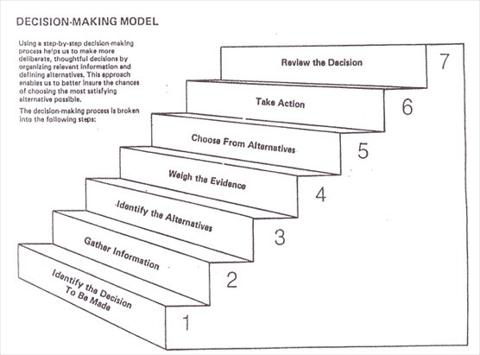

Really? That’s what you thought? Alright boys, consider this. It’s Sachin’s last cricket test match today. As luck has it, your crush has agreed to go out for a movie with you on the same day. What’s your decision now? Tough call, isn’t it? Girls face a similar dilemma when they have to choose one between a lovely peplum dress from Zara and gorgeous pump heels from Aldo.

We take decisions every day. Every little action requires us to analyze its reaction. And of course, we have to think about how that reaction will affect us. What all goes into this ‘process’ of decision making?

Decision is a conclusion we reach at, after taking every possibility into consideration. Our daily routine revolves around the decisions we have taken or we will take in future. Small or big, decisions affect each and every person and the association it is involved with. So, it is an important aspect of Management.

Whenever we think of a leader or manager, the first thing that comes to our mind is if the person is able to take accurate decisions in a given time and if he can decide the better option from the given alternatives.

Whenever one is taking a decision, the foremost priority is to keep in mind the profit or loss that might result from each alternative. Wherever we have to take a decision, there are some factors which cause problems and are common in every field, be it public or private sector. There are always some events which are not at all under the decision maker's control (which in managerial terms are called *states of nature*) and their existence causes great difficulties. We can understand this with the help of example. If you are a manager in some production industry, then there will be motor burnouts. It’s your decision to do preventive maintenance. Instead you decide to keep spare parts. However, you have no control over the burnout and what may be the rquirement of the machinery at that particular point.

Now comes the uncertainties concerning with these states of nature. What will actually happen if the decision is taken? The manager would never know how many burnouts may take place and how many spare machinery would be required. The main criteria on the basis of which the decision is taken is the **expected value.** The alternative with expected profit is the better decision. But there are situations in which this is not the only dominating factor. Sometimes the decision to be taken solely depends upon the **utility.** Utility is the pleasure or displeasure that a certain outcome will derive. To understand utility we can take an example. In a bet with your friend over a toss of coin, he decides to pay you double if you win while you have to pay only the amount you betted to him. This bet started with ten bucks. You accepted the deal but he when wants to bet on ten thousand bucks (Yeah, your friend is greedy), you probably will ask him to stop playing around and do his work. Even though the expected outcome is attractive the thought of losing your money i.e. the utility here is prominent over the outcome.

Whenever a decision is taken, a number of factors are to be taken care of. Now the tricky part is, even then one cannot be hundred percent sure whether he/she is right. So the next time you take a decision, just keep in mind all the pros and cons. Remember, not all decisions can lead to a positive result. And it’s good to make mistakes sometimes, they help you learn faster.

Good Luck.

(For the icon)

